**LAPORAN DOKUMENTASI UJI KOMPETENSI KEAHLIAN**

**( UKK)**



**Disusun Oleh :**

**Sifa Nurma Zunifah**

**2210882**

**PENGEMBANGAN PERANGKAT LUNAK & GIM**

**SMK MA’ARIF WALISONGO KAJORAN**

**TAHUN AJARAN 2024/2025**

1. **Program yang di instal**

* XAMPP
* Visual Studio Code
* Chrome
* Sublim Text
* File Manager

1. **Spefisikasi Laptop**

* Device name DESKTOP-1DCNI1V
* Processor Intel(R) Core(TM) i5-3340M CPU @ 2.70GHz 2.70 GHz
* Installed RAM 6.00 GB (5.85 GB usable)
* Device ID 353F2912-6787-4819-9EB0-83EA2655EE6C
* Product ID 00330-80000-00000-AA286
* System type 64-bit operating system, x64-based processor
* Pen and touch No pen or touch input is available for this display
* Edition Windows 10 Pro
* Version 22H2
* Installed on ‎12/‎7/‎2019
* OS build 19045.5371
* Experience Windows Feature Experience Pack 1000.19060.1000.0

1. **Desain Interface**

**Login**

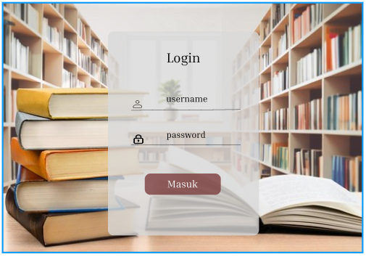

**Dashboard**

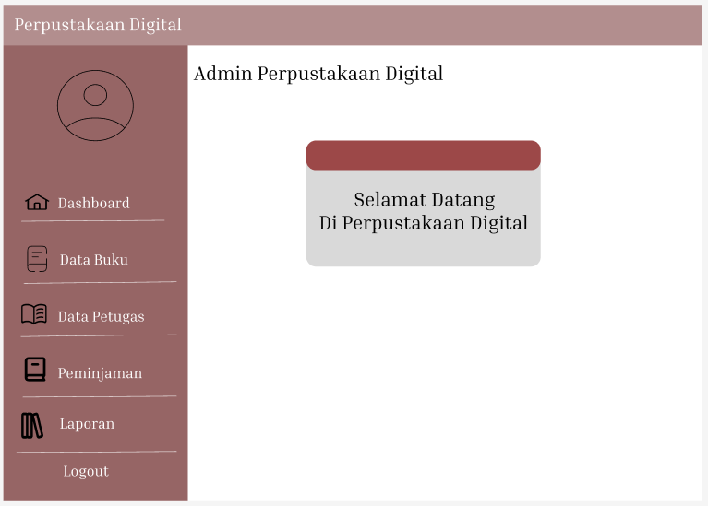

1. **DFD**

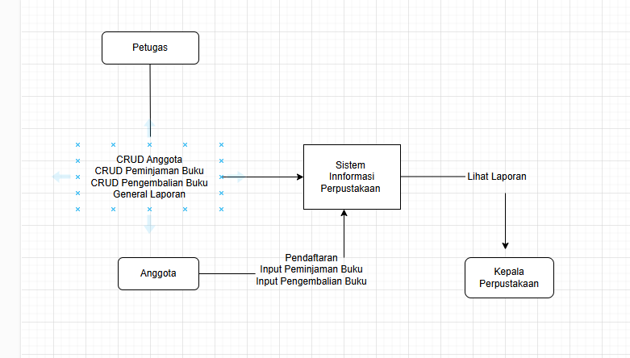

**Dashboard**

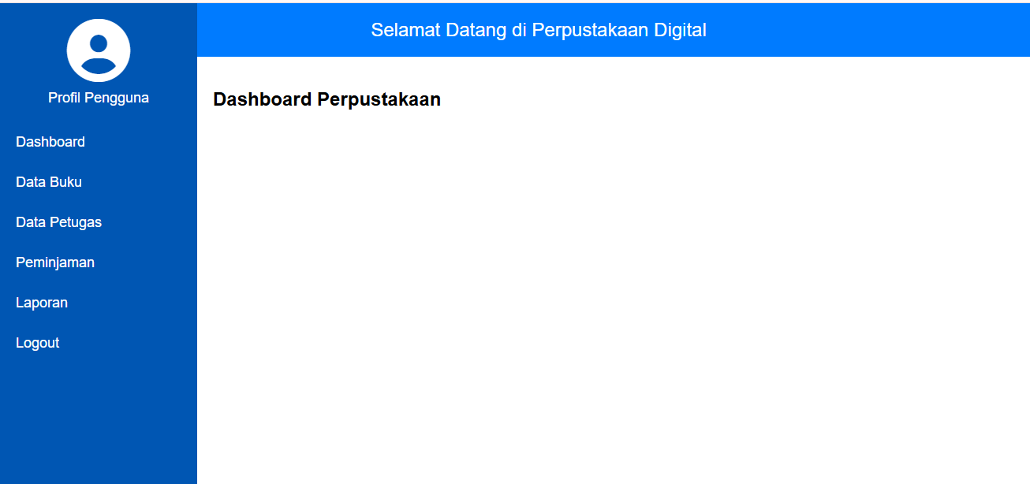

**Data Buku**

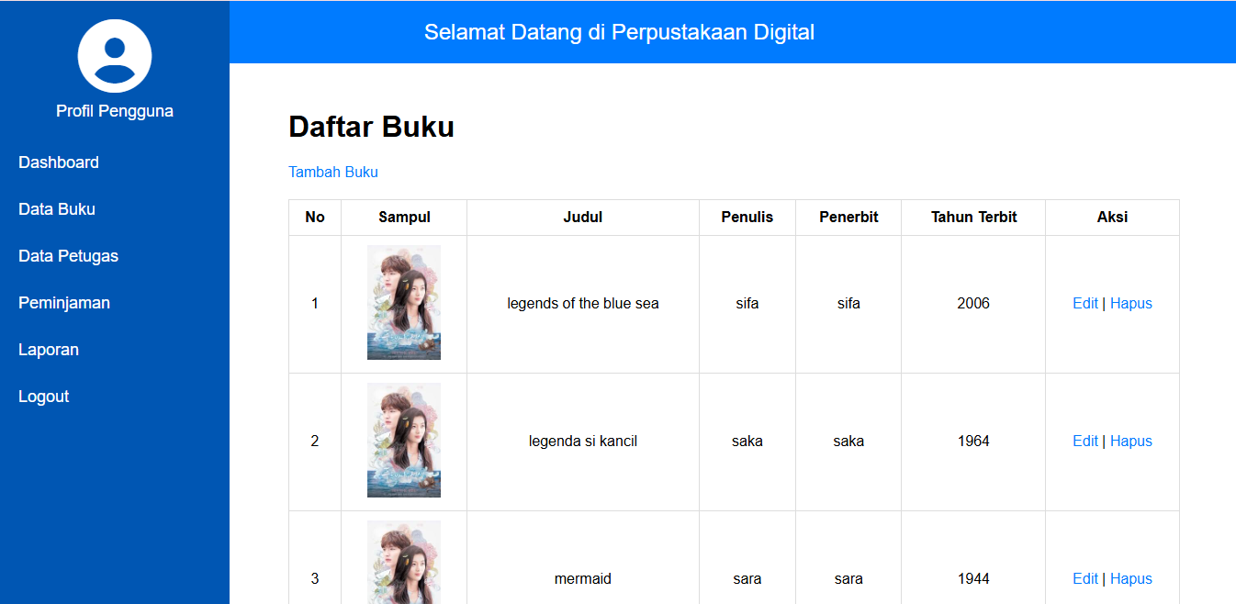

1. **Fitur yang Jadi**

**Login**

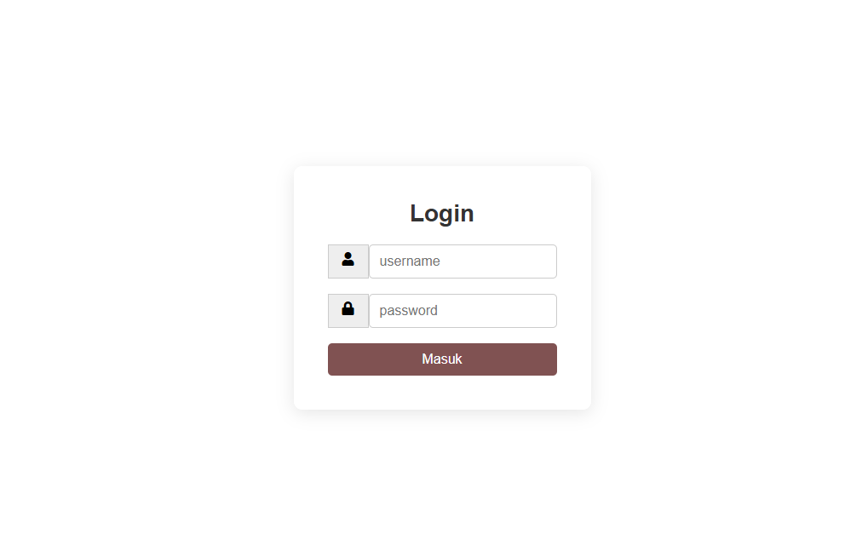

**Tambah Buku**

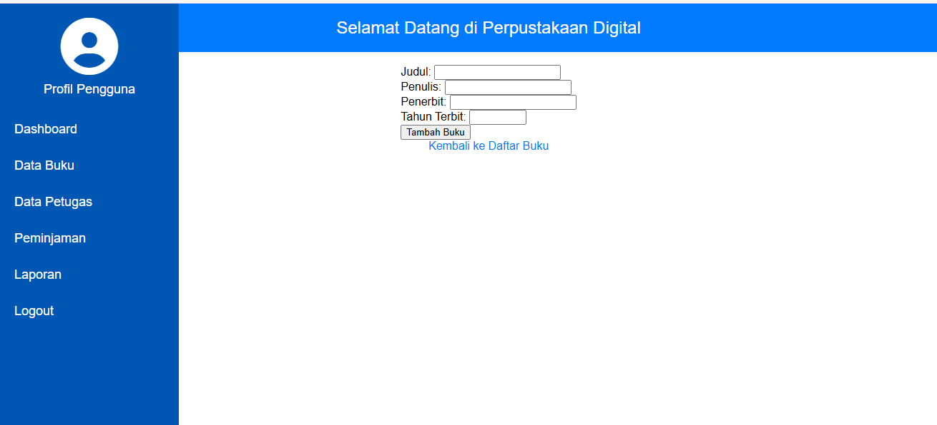

**Edit Buku**

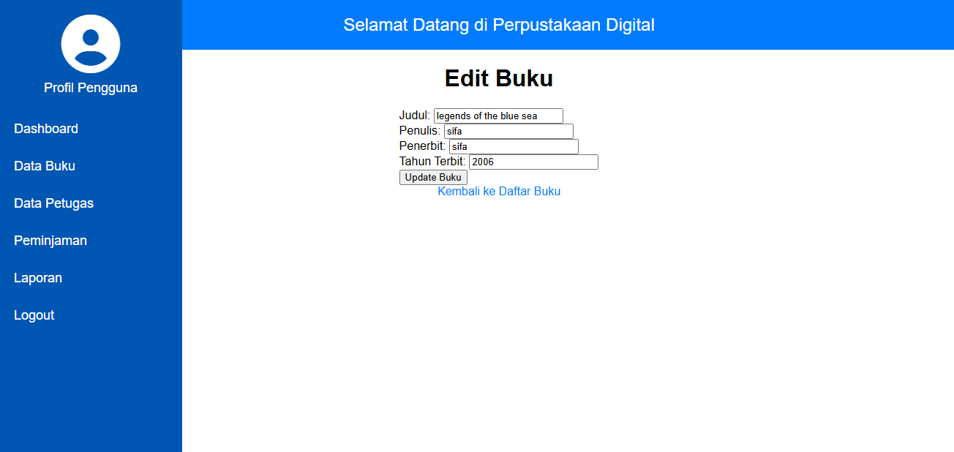

**Hapus Buku**

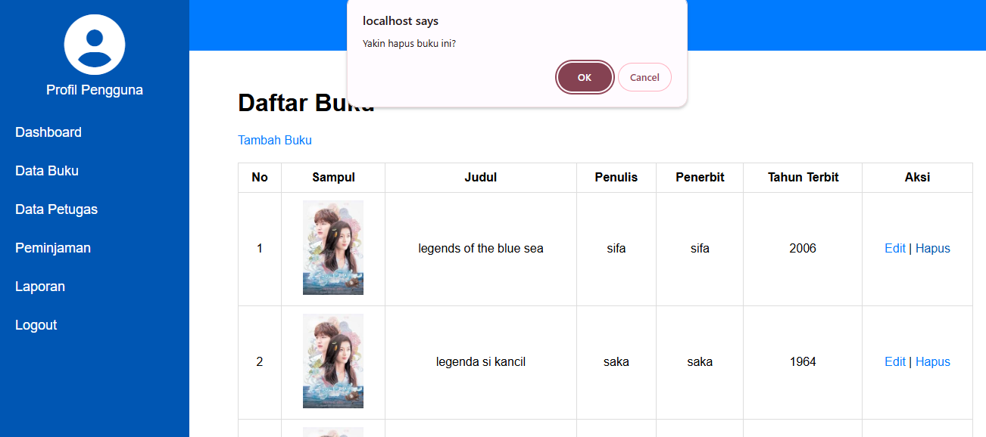

**Data Petugas**

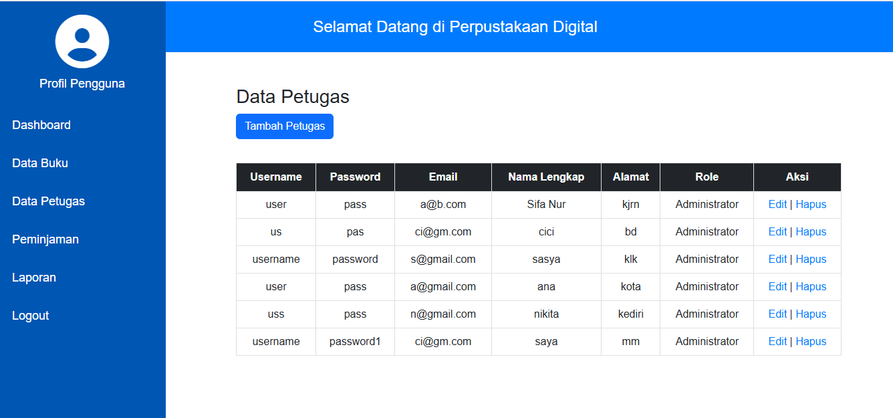

**Data Peminjaman**

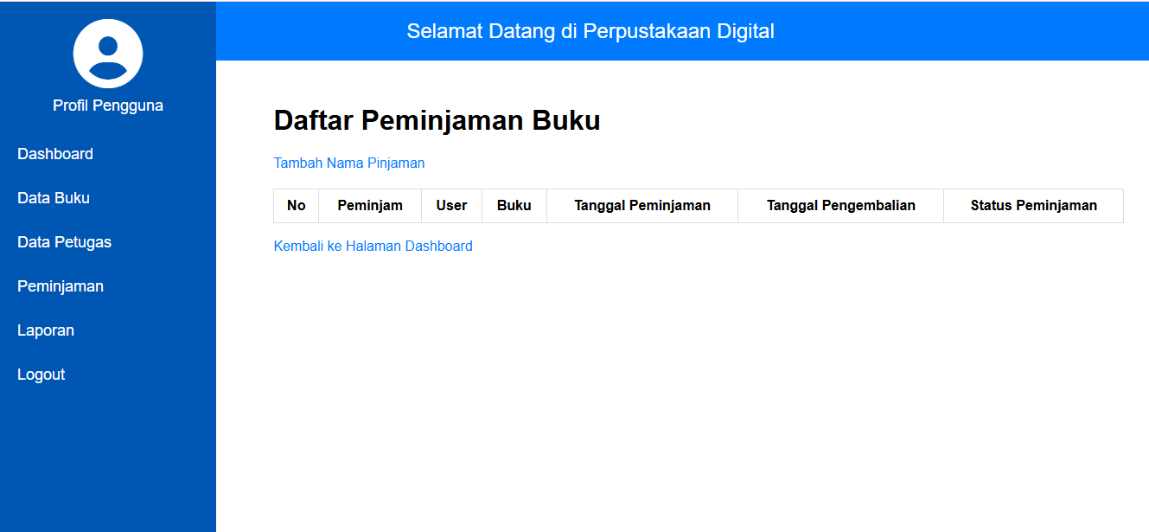

**Tambah Peminjaman**

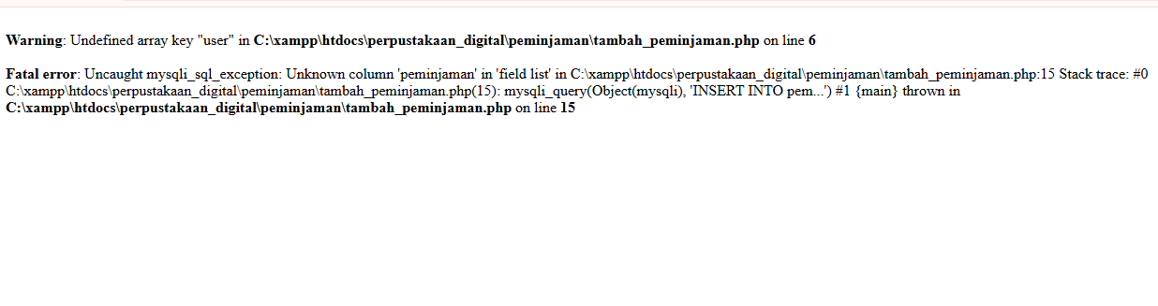

**Eror karena belum bisa mengkoneksikan ke database**